Key Management Server (KMS) Program
Program Guide v.3.1

Copyright © 2019 VMware, Inc. All rights reserved.
VMware is a registered trademark or trademark of VMware, Inc. in the United States and/or other jurisdictions.
All other marks and names mentioned herein may be trademarks of their respective companies.
VMware, Inc. 3401 Hillview Avenue, Palo Alto, CA 94304 USA. Tel: 877-486-9273 Fax: 650-427-5001
Revision History
Version | Date | Change Summary
1.0 | 02 28 2017 | Program Launch Version
2.0 | 10.17.2017 | Cloud Certification Release (GA)
3.0 | 06.30.2018 | TAP membership – new model rollout
3.1 | 03.22.2019 | Appendix H updated for 7.x

Contents
1 Introduction 6
1.1 Overview of This Guide 6
1.2 General Participation Requirements 6
2 Membership Signup, Renewal, and Termination 8
2.1 Joining or Renewing Program Membership 8
2.2 Termination of Program Membership 8
2.3 Removal of Program from SDDC Foundation and Integration Program 8
3 Program Components and Process Flow 8
3.1 Program Guidelines 9
3.1.1 Program Guidelines and Agreements 9
3.1.2 Program Fees 9
3.1.2.1 Program Entrance Fee 9
3.1.2.2 Development Consulting Fee 9
3.1.2.3 Certification Log Submission, Support, and Equivalency Fee 9
3.2 Pre-Release Development and Certification Engagement 10
3.2.1 Engineering Support 10
3.2.1.1 Partner Contacts 10
3.2.1.2 Partner Internal Triaging Process for Suspected VMware Software Issues 10
3.2.2 VMware Products and Development Kit 10
3.2.3 Certification 11
3.3 Release Logistics 2
3.3.1 Packaging and Installation 2
3.3.1.1 Packaging 2
3.3.1.2 Delivery to Customers 3
3.3.1.3 Installation 3
3.3.1.4 Open Source and Encryption 3
3.3.1.5 VMware Signed Software 3
3.3.2 Hosting 3
3.3.2.1 VMware Hosting 3
3.3.2.2 Partner Hosting 3
3.3.3 VMware Compatibility Guide (VCG) Posting 4
3.3.4 Supporting Documentation Requirements 4
3.3.5 VMware Ready Logos 4
3.4 Post-Release Activities 5
3.4.1 Partner Software Support Policy 5
3.4.1.1 Support Readiness 5
3.4.1.2 Hosting of Collaborative Technical Support Process for Mutual Customers 5
3.4.1.3 Partner Support Experience 6
3.4.1.4 Support Requirements and Process 7
3.4.1.5 Transfer of Information (TOI) 7
3.4.1.6 Recommended Partner Training 7
3.4.2 Sustaining Policy 7
3.4.2.1 Hot Fix Process 7
3.4.2.2 Re-Certification of Modified Partner Software 8
3.4.3 VMware Workbench, Dev Kits, and Cert Kits Support Lifecycle Policy 8
4 Re-Validation 9
4.1 VMware Platform Triggers 9
4.2 VMware Product Backward Compatibility 9
4.3 Partner Software Qualification Triggers 9
4.4 Compatibility/Equivalency Claim Process 9
5 Contact Information 10
6 VMware Release Milestones 10
Appendix A: Additional Information 11
Appendix B: Key Web Links 12
Product-Specific Information 12
VMware Product Downloads 12
General Support Resources 12
Appendix C: VMware Customer Contacts Support Flow 13
Appendix D: Partner Customer Contacts Support Flow 14
Appendix E: Transfer of Information (TOI) 15
Appendix F: Sample Partner Contact Information Form 16
Appendix G: Glossary of Terms and Acronyms 17
Appendix H: VMware Pre-Release Material(s) and Development Kit(s) 18
Appendix I: Digital Signing Process for Partner Signed Software 19

Introduction
Welcome to the Key Management Server (KMS) Program (referred to as the “Program” herein and as the “Program Category” within the VMware Platform Extensibility Program Agreement). This Program is designed to allow Partners to develop Key Management Servers that are KMIP 1.1 Compliant (hereinafter referred to as “Partner Software”) which will run with vSphere 6.5. The VM Encryption feature was introduced with vSphere 6.5. In version 1.0 of this Program, KMS are restricted to only VM Encryption certification. The goal is to generalize this Program over time to include vSAN (vSan is already included) and IO Filters and other feature categories, but we are limiting the supported use cases for this version. Our goal is to allow our Partners to certify key management servers on the vSphere platforms. This program is offered as part of the SDDC Integration Program.

Overview of This Guide
This document explains the Program requirements, as well as the engagement, support, maintenance models and lifecycle of the Program. For more detailed certification requirements, refer to the relevant certification guides available on the Program website. Capitalized terms used in this Program Guide have the same meaning as defined in the Agreement unless otherwise defined herein. To the extent there is any inconsistency between the Agreement, the Program Addendum, and this Program Guide, the documents will govern in the following order of precedent: the Program Addendum, the Agreement, and then this Program Guide.

General Participation Requirements
Partner must meet the following requirements to engage in the Program:
- Establish and maintain membership in the VMware Technology Alliance Partner (TAP).
- Sign the appropriate Program agreements as referenced below (“Agreement”) as determined by VMware.
  - The VMware Platform Extensibility Program Agreement (the “PEPA”) and the Software Defined Data Center Foundation and Integration Program Addendum (the “Program Addendum”) entered into by VMware and Partner will govern Partner’s participation in the Program.
- Meet and follow Partner Software support requirements (outlined in Section 3.4 “Post-Release Activities”).
- Provide VMware with details about timeframes for submitting certification logs for certification tests.
- Provide VMware details about development and support timeframes with respect to new Partner Software.
- Follow Program instructions for all pre-requisites to be met for the VMware Compatibility Guide (vCG) listing.
This Program may be amended periodically at the sole discretion of VMware, including but not limited to changes regarding the following:
- Requirements for TAP program enrollment
- Business and engineering processes to certify providers
- Certification tools, documentation, or other related materials
- Policies to list Partner Software on the vCG website or VMware.com, where applicable
When there is a change to this Program Guide, VMware will notify Partner through appropriate communication channels. Partner is responsible for ensuring that the communication channel with VMware is open and effective for compliance with VMware changes promptly.
Membership in the Program is effective on the effective date of the applicable Program Addendum.

Membership Signup, Renewal, and Termination

Joining or Renewing Program Membership
Program membership is effective and valid for the duration specified in the Agreement. Each Program will be updated for each release of the corresponding VMware product that introduces significant new functionality and during this process VMware may change the Program enrollment requirements. Existing Partners will be allowed to continue to participate in the updated Program only if they meet the updated Program enrollment requirements.

Termination of Program Membership
Upon termination of the Agreement or the Program Addendum, Partner’s Program membership into the Program is terminated and as a result, the Program collateral and Program website will no longer be accessible to the Partner. For details on termination, please review the “Term and Termination” Section of the Agreement and the Program Addendum.

Removal of Program from SDDC Foundation and Integration Program
VMware may, at its sole discretion, remove the Program from the Program Addendum. In such event, Partner will no longer have access to the Program’s collateral or access to the Program website. However, the Partner’s access to the collateral and websites of other programs that remain as part of the SDDC Foundation and Integration Program will not change.

Program Components and Process Flow
The Program provides a full spectrum of resources to guide Partners in developing, releasing, and supporting their Partner Software.
There are four Program components:
- Program Guidelines and Agreements
- Pre-Release Development and Certification Engagement
- Release Logistics
- Post-Release Activities
Distribution and Landing Page
VMware Compatibility Guide
Release Logistics
TOI to VMware GSS
TSANet for Mutual Customer Scenarios
Maintenance
Release Process
Post-Release Activities
TAP Agreement
Program Agreement
Program Guide
Access to VMware Product & Platform Specifications
Program Guidelines
Development Kit
Certification Kit
Development Consulting
VMware Beta
Certification Suite
Pre-Release Engineering
Figure 1: Program Components.
The remainder of this section elaborates on the components of this Program.

Program Guidelines
This Program component includes the non-technical elements of the Program.

Program Guidelines and Agreements
This Program Guide and the Agreement provide the terms and conditions of this Program. Partners must agree to the terms of these documents to participate in this Program. This Program Guide is subject to change. Qualification Requirements are specified in the product Certification Guide, which is posted on the Program website.

Program Fees
VMware may, in its sole discretion, waive any or all of the fees associated with this Program. For exact fee amounts, please contact your VMware representative directly. Below is a description of various fees that may be applicable to the Program.

Program Entrance Fee
The Program Entrance Fee is applicable to the specific version of the Program for which it was purchased and is a one-time, non-refundable, and non-transferable fee. The Program Entrance Fee is stated in the Program Guide applicable to the SDDC Foundation and Integration Program.

Development Consulting Fee
The Development Consulting fee provides Development Consulting via the Program website. Partners may renew the Development Consulting services as set forth in the Agreement. This is an optional service that partners may avail themselves of should they need engineering assistance.
For more information, please contact your Program Manager.

Certification Log Submission, Support, and Equivalency Fee
Service Request (SR) if used to submit logs for review or for certification questions. Prior to submitting a SR, each Partner shall purchase from the VMware Store a certification log submission for log review per SR (http://store.vmware.com/store/vmware/en_US/pd/productID.283500200). For certification support, follow the same process after purchasing from http://store.vmware.com/store/vmware/en_US/pd/productID.283466100. A service description can be found in the datasheet for your Program on the VMware Store website: http://www.vmware.com/go/enablement
All Partners are required to pay the Log submission, support, and equivalency fees as applicable. This improves the cert review process and provides timely VCG listings. Details on how to purchase entitlements for the certification submission are provided as part of the Program collateral on the Program website.

Pre-Release Development and Certification Engagement
This Program component includes the tools and resources available for the development and certification of Partner Software. All of the tools are available via the Program website.

Engineering Support
Partners in the Program will have access to the Program website, which hosts the Developer Kit(s), which include code samples and other resources for developing the Partner Software. Additionally, availing of this support enables Partner teams to communicate with VMware about technical issues around development of the Partner Software. VMware provides development and testing consultation through the Program website, using collaboration tools, or via the telephone during pre-arranged conference calls. The Agreement will state the fees due for these services.

Partner Contacts
This Program uses a co-development process that requires Partners to identify a primary point of contact (such as a Program Manager) and an Engineering Manager and/or Technical Lead. Please complete the form in Appendix F: Sample Partner Contact Information Form and post the information in the “Documents” folder of your private project on the Program website. Please note that VMware does not publish the contact information on any public site.

Partner Internal Triaging Process for Suspected VMware Software Issues
The Partner’s Engineering Manager and/or Technical Lead shall review all suspected VMware software issues prior to the team engaging the VMware co-development engineers. Partner technical contacts shall include the internal assessment (including logs etc.) when filing a question for the VMware Engineering Team.

VMware Products and Development Kit
Partners will receive access to certain Pre-Release Materials and/or Development Kits, as determined by VMware. The current listing is set forth in Appendix H: VMware Pre-Release Material(s) and Development Kit(s). The Pre-Release Materials and/or Development Kits may be used only in compliance with the Agreement.
VMware provides access to the applicable Pre-Release Materials and/or Development via:
- Official milestones, such as the official beta program for beta, RC, and GA milestones.
- Unofficial milestones, which refers to any point in time other than beta, RC, and RTM. To request access to such bits, please contact your EE Program Manager and provide a short justification.
As part of unofficial-milestone build delivery, VMware provides beta-type builds. When choosing to use such builds, please note the following:
- Only the ESXi installer bits are provided as beta-type builds.
- Beta-type and release-type builds are built from the same VMware change-list, but they do not have the same checksum.
- Beta-type and release-type builds are functionally the same for development kit files; checksum differences do not indicate a real difference.
- Mixing different build types might lead to PSODs and unpredictable behavior.
Scalability and timing-sensitive functionality should be qualified only on release-type builds. Beta-type builds include debugging code.

Certification
Partner Software certification is generally considered to be one of the most important parts of the development process. The Program Certification Guide sets forth the Qualification Requirements and is available on the respective Program website. The Program Certification Guide is designed to guide Partners in qualifying Partner Software to VMware standards.
The following links detail the certification levels and the support structure:
• http://pubs.vmware.com/vsphere-50/index.jsp?topic=%2Fcom.vmware.vsphere.upgrade.doc_50%2FGUID-27BBBAB8-01EA-4238-8140-1C3C3EFC0AA6.html
• https://www.vmware.com/support/policies/thirdparty
This Program falls under the “VMware Certified” level of certification for Partner Software testing. This level carries the guidelines and benefits shown in Table 1:
Table 1: VMware Acceptance Levels.
Acceptance Level | Customer Support Provider | Testing Program | Process Flow
VMware Certified | VMware | Certification (Functional Verification) | Appendix C
VMware Accepted | Partner | Acceptance (Provider doesn’t misbehave) | Appendix D
Partner Supported | Partner | Partner-defined | Appendix D
Community Supported | None | None | No Support Flow

The certification process begins after a Partner develops Partner Software and has completed internal QA tests and is confident the Partner Software can pass the certification suite.
Partner software solutions must be certified in order for Partner to distribute it. Certified Partner Key Management Solutions will be eligible to receive a VMware Ready logo following the technical validation process. For details please refer to the section on “VMware Ready Logo” section below.
Before the Key Management Solution is ready for certification testing, Partners should file a case on DCPN to request access the KMS test lab provisioned in the Cloud. “Cloud” means a lab environment hosted and managed by VMware on its cloud. The KMS certification link on code.vmware.com will provide all the details on the form used to request this access etc. Partners should follow the certification requirements as outlined in the Certification Guide to self test the Key Management Server Solution. This will require that Partners upload their Key Management Solution to VMware Cloud and run the tests in the cloud setup.
Once testing is complete, the Partner uploads the test results to VMware, using the Workbench plugin. VMware verifies the results and either certifies the Partner Software or denies certification with due justification.
For Partners developing Software with a Software Development Kit, revisiting the following to provide a superior customer experience is recommended:
- Partner landing page recommendations
- Recommended Partner Software documentation
- Requested troubleshooting error codes documentation
- Partner support statement and support policy
- Product hosting information as applicable
- Bundling of the Partner Software with documentation
Upon successful certification, VMware updates the VMware Compatibility Guide (VCG) website to include the applicable version of the Partner Software.
The Agreement requires that Partners (if they choose to distribute their Partner Software) distribute only Partner Software that has successfully passed the certification tests and Qualification Requirements under this Program. Customer or field complaints that reveal non-compliance will result in delisting the Partner Software from the VMware Compatibility Guide (VCG)

Release Logistics
This Program component covers activities related to the release and availability of Partner Software developed and certified under this Program.

Packaging and Installation
This Section discusses some of the best practices and logistics of Partner Software packaging and installation.

Packaging
VMware recommends that Partner Software be packaged as an executable, containing a self-extracting, self-installing file where applicable. Zip all Partner Software documentation as part of the Partner Software download bundle, but keep docs separate from the installer/executable. Keeping the documentation zipped separately makes doc updates possible without going through the re-test waiver process.
Ship Partner Software with the following documentation in a single compressed archive (.zip) file:
- Release Notes with version-specific information for the following:
- What was fixed
- What was added
- Known bugs
- Release Note organization to stay consistent over time and versions, with history included
- Installation Guide and Configuration Guide, to include the following where applicable
- Prerequisites. For example: Java run-time environment, .NET, etc.
- Supported configurations with at least one simple, hardened test configuration, which should allow the Partner Software to perform all functions (the “proof case”).
VMware can use this example to confirm that there are no configuration issues in the customer environment and triage the issues appropriately.
- Any licensing assumptions spelled out explicitly; details of any encryption being used.
- Troubleshooting guide spelling out common error messages and typical configuration misunderstandings.
- Process explaining how to engage your support for the Partner Software, as follows:
- Which logs to have handy and how to collect them
- What Partner Software information to gather for each type of problem (screenshots, array managers, replicated volumes, and so forth)
- Contact protocol with URLs and toll-free telephone numbers
- Any entitlement identity that might be required for support
Each and every version, release, patch, and hot fix of the Partner Software should clearly identify itself with a fully qualified and dated release signature, at least once for every request that it handles. (Make the release signatures clearly visible in the logs whenever the Partner Software is working and include a unique release signature, insomuch as the date and at least one node of the version should be different from all other released Partner Software.
Partner Software must have version number designations. This helps users quickly discern the version without having to examine logs or open other windows or facilities.
Note: Be sure to remove all references to VMware trademarks or product names as part of Partner Software name during installation and post-installation for Partner Software listings.

Delivery to Customers
Once Partner Software has been packaged accordingly, Partners can then distribute their Partner Software to end customers from a page on their own website. The download bundle should contain all documentation that is listed as required under the Supporting Documentation Requirements Section.

Installation
During extraction or installation, Partner must present their End User License Agreement (EULA) to customers in a way that requires the customer to accept the Partner EULA prior to use of the Partner Software. If a user does not accept the EULA, the Partner Software must not install.
Customers must be presented with the option of opening documentation files after installation completes. The documentation should include a link to a webpage and customer help system that is maintained by the Partner. The customer must not be required to copy files to specific places, nor required to edit any files to configure the Partner Software.
Both the Partner Software, and vSphere 6.5 (with VM Encryption feature) need to be installed for an operational solution.

Open Source and Encryption
Partners are expected to comply with all applicable third-party and free / open-source licenses and meet all applicable import, export, and re-export control obligations.

VMware Signed Software
If Partner wishes to distribute Partner Software that meets Qualification Requirements, under this Program, NO digital signing is required prior to distributing certified partner software.

Hosting

VMware Hosting
VMware does not host Partner Software under this Program. Partners can publish their plug-ins on VMware Solution Exchange and use the VMware Ready Logo for certified Partner Software.

Partner Hosting
Partners who choose to host Partner Software on their website are encouraged to consider the following recommendations for the Partner Software landing page.
Landing Page Recommendations:
- Publicly available landing page (The link must be a live link and not result in a 404 unknown error or send users to a generic, “we can’t find the page you are looking for” site.) It is OK for the landing page to require credentials to log in.
- Viewable with standard browsers
- Public statement of the Partner’s support policy for their certified Partner Software. (Include a link to the support policy or information on how to get support.)
- Stated support is not beyond VMware stated support (features, versions, array models, etc.).
- Link to VMware Compatibility Guide listings.
Static Information:
- About VMware product text from VMware.com or VMware approved collateral.
- A public statement of the Partner’s support policy for their Partner Software. (Include a link to the support policy or information on how to get support for released Partner Software). This information should be provided to VMware support for review prior to GA of the Partner Software.
- Link to VCG website.
Partner Software Information:
- Text that describes features/bug fixes included in that Partner Software version
- Product documentation and installation information (include any software and/or hardware prerequisite; best practices/user guide, among others)
- Product download details (download bundle should include all relevant documentation listed on the landing page)
- Product version
- Date certified/released
- MD5 SUM and SHA1 SUM
- File size

VMware Compatibility Guide (VCG) Posting
Partners must officially state the combinations of versions of the VMware product. VMware reserves the right to conduct its own compatibility testing to validate Partner’s compatibility claims.
The compatibility for Partner Software that is “certified” is posted on the VMware Compatibility Guide website. VMware technical support is obligated to support Partner Software only with the equipment and management interfaces agreed between the Partner and VMware, contained in the VCG.
Other clarifications for VCG posting:
- VMware uses footnotes and Knowledge Base (KB) articles to document known Partner Software incompatibilities. If an incompatibility is severe enough such that the Partner Software is not supportable, the Partner Software is not posted on the VCG website until a technical fix is provided.
- VMware determines whether an incompatibility is sufficient to footnote or to deny a certain posting, or to remove any listing at any time.
- VMware removes Partner Software from the VCG listing upon Partner request or at its own discretion.
- In the spirit of joint support, VMware does not claim support for Partner Software beyond those that are certified.

Supporting Documentation Requirements
VMware Support requests that Partners provide links to all relevant TOI material described in Appendix E: Transfer of Information (TOI).

VMware Ready Logos
Once Partner has certified the Partner Software under the terms of the Program, the Partner may use the VMware Ready™ logo in their Partner Software collateral, as set forth in the Agreement. For details please refer to the VMware Ready program link.

Post-Release Activities
This Program component includes support and sustaining policies for Partner Software.

Partner Software Support Policy
Unless otherwise approved in writing by VMware, Partners must provide a public statement of their support policy for Partner Software that can be linked from the Partner-landing page. This public-facing statement should be ready and released prior to GA of the Partner Software, or, if not applicable, prior to posting of the certified Partner Software on the VCG.
Support and troubleshooting of all Partner Software is the responsibility of Partner as per Partner’s documented support policy.
For entitled support issues reported to VMware, VMware Global Support Services (GSS) assists customers in problem analysis and resolution. In the event the issue is diagnosed to be directly related to Partner hardware or software, GSS works with the customer to open a collaborative support request (SR) with the Partner. The support flow for the SR follows the VMware support process, as outlined in Appendix C: VMware Customer Contacts Support Flow.

Support Readiness
The goal for the Partner Software support policy is to ensure an excellent post-sale support experience for the mutual customer, and to drive best of breed customer satisfaction for Partner and VMware. In order for Partner and VMware to be successful with this goal and Program, VMware expects the Partner to provide the following:
- A clearly defined process and escalation contacts between VMware Technical Support and Partner’s technical support organizations, to engage each other for smooth handoffs and collaboration for all SRs related to Partner’s Partner Software. This process should establish a Senior Support Engineer-to-Senior Support Engineer relationship. For critical escalation, this process should also provide an Escalation Manager-to-Escalation Manager relationship.
- Partner shall provide ability for VMware GSS to be able to open tickets directly with Partner for the sole purpose of troubleshooting mutual customer SRs.
- Partners shall ensure adequate support readiness and training of their support organization to support the Partner Software. Partners must have a support infrastructure in place to appropriately route and track all SRs related to their Partner Software. Additionally, Partner technical support engineers must be trained to have a reasonable understanding of the applicable VMware Partner Software, in order to assist during troubleshooting during any collaborative support effort between VMware and the Partner’s support team for a mutual customer situation. To provide the best possible customer support, Partners must have one VMware Certified Professional (VCP) support staff onboard. Partner support teams must be ready to support the Partner Software at or before the general availability date of the Partner Software.
- Partners should appoint a designated technical support contact who is primarily responsible for the support relationship with VMware support organization. This person shall be responsible and shall act as a single point of contact for all support-related activities, including escalations and management of the cooperative support process relationship. This person shall ensure the overall support readiness and training of their support organization to support Partner Software.
- Communications of any changes, updates, patches, etc.to the Partner Software, are to be communicated back to VMware at least 14 days before release to the general public.

Hosting of Collaborative Technical Support Process for Mutual Customers
Partner agrees to post current valid support and escalation processes related to Partner Software as part of the VMware dedicated or custom Technical Support Alliance Network (“TSANet”).
For the duration of a Partner’s participation in this Program, and to retain certification status, the Partner must maintain membership in the Technical Support Alliance Network. Please find the details at the “TSANet” website, https://vmware-tap.tsanet.org and as such join the VMware Private TSANet Community. Any issues found with Partner Software are handled by the corresponding Partner, as described in the Third-Party Hardware and Software Support Policy documentation at http://www.vmware.com/support/policies/ThirdParty.html.
Partner shall comply with specific terms and recommendations regarding validation, support, and associated customer communication, as outlined in TSANet guidelines and in this Program Guide.

Partner Support Experience
Partner shall open a Support Request with VMware on behalf of an end user via the TSANet channel, when the customer support issue is specifically isolated to a VMware product, or only reproducible on a VMware platform. Partner must resolve the support ticket in accordance with the applicable support agreement between the customer and the Partner.
VMware GSS Product Support Teams do not support SDK APIs. During customer situations, if the issue requires troubleshooting of SDK API calls, then Partner should take the lead and work with VMware Developer Support in the background.
The Support Call flow for SDK API related issues is shown in Figure 2:
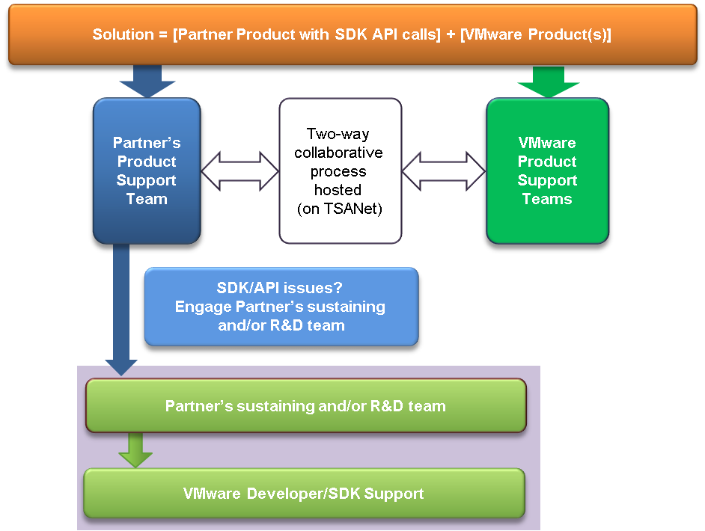

Figure 2: SDK API Support Call Flow.

Support Requirements and Process
General Support Terms:
- Partners are requested to provide the “volume” information of customer support issues reported against their Partner Software (open/resolved.)
- Failure to fulfill and/or keep current with support requirements will result in non-compliance from certification perspective.

Support Request Process:
- End users can report software stability and performance issues to VMware. If they have reason to believe this is a VMware issue and, provided that the Partner’s software is listed on the VCG website.
- For any issues related to the Partner’s Software, VMware shall initiate a request for technical assistance from the Partner by following the Partner’s support process and procedures posted on TSANet.
- KBs (Knowledge Base articles) are recommended for all Partner Software issues or knowledge that will help end users. VMware provides a link to KBs from the product VCG. http://blogs.vmware.com/vsphere/2012/05/oldies-but-goodies-site-recovery-manager-setup-videos.html
http://kb.vmware.com/selfservice/microsites/search.do?language=en_US&cmd=displayKC&externalId=1014610
- VMware and Partners shall work cooperatively to troubleshoot issues to resolution (see also the flowcharts in Appendix C: VMware Customer Contacts Support Flow and Appendix D: Partner Customer Contacts Support Flow).

Transfer of Information (TOI)
Partners are required to provide a training session with select VMware groups on the specifics of the Partner Software. For details regarding the content of the training, refer to Appendix E: Transfer of Information (TOI). The KMS Program will require a recorded TOI for VMware GSS to provide top quality customer support.

Recommended Partner Training
To provide the best possible customer support, VMware recommends that Partners have one VMware Certified Professional (VCP) support staff on board. To become a VMware Certified Professional, please visit www.vmware.com/services/certification.html to learn about the required instructor-led courses.

Sustaining Policy
Partners are responsible for maintaining their Partner Software by fixing any bugs or security issues and by updating and/or upgrading the software to support new or existing applicable VMware product(s) in a timely manner, as long as the VMware support policy is applicable for that release.
Note that any major change to the Partner Software might affect the certification status. It is highly recommended that the Partner Engineering team work closely with the VMware Program Manager during the Partner Software sustaining process. See Section 3.4.2.1 “Hot Fix Process” for details on how to provide customers with a Hot Fix, as well as on how to re-certify a modified Partner Software.
Should the need arise to provide a customer an immediate fix to address an urgent issue (a “Hot Fix”), Partners must follow the process defined below. To make the Hot Fix available to all customers, Partners must either submit a full re-certification of the modified Partner Software or follow the process outlined in Section 3.4.2.1.

Hot Fix Process
VMware considers a Hot Fix to be a fix addressing a specific critical issue found by one or more customers. A Hot Fix is not a mechanism to add features or functionality to existing Partner Software. When a Hot Fix is necessary, the Partner generates the Hot Fix and notifies VMware that the fix was created, tested, and distributed to those experiencing the problem addressed by the Hot Fix. Partners are strongly urged to run at least a subset of the certification tests against a Hot Fix before releasing it.
Partners must provide a detailed description of the bug and its symptoms to VMware, so that VMware support can direct customers who file new reports of the bug to Partner. This information must be communicated to VMware by completing the Partner Software Hot Fix Notification Form, available on the developer collaboration site. Partner’s support organization shall distribute the Hot Fix on a customer-by-customer basis, via a non-public distribution mechanism. Partner shall also provide an estimate as to when the fix can be rolled into an update to the Partner Software, and shall request a review slot with VMware.
In cases where a Hot Fix is not widely distributed (posted version of Partner Software), Partners are advised to track these customer distributions for support calls. Partner shall also provide the Hot Fix itself to VMware, with instructions on how to install the Hot Fix. Any changes to the Partner Software must be re-certified, as described in Section 3.4.2.2 “Re-Certification of Modified Partner Software.”

Re-Certification of Modified Partner Software
If a Partner modifies certified Partner Software, internal QA tests should run successfully before requesting the revised Partner Software to be considered by VMware for re-certification. Running all certification tests is recommended, but running a subset of the certification tests might be sufficient, if the following conditions are met:
- Partner helps VMware understand the nature, scope, and impact of the changes;
- Partner provides pointers to the user and reference documentation for relevant versions used to build the Partner Software
- Partner provides a list of changes and detailed explanations thereof.
Partners must complete a Re-Test Waiver form and submit this form along with any other applicable information (e.g., test results, source code, diffs, etc.) in the same folder where the Hot Fix notification form was submitted.

VMware Workbench, Dev Kits, and Cert Kits Support Lifecycle Policy
Details of this policy are available online at: https://developercenter.vmware.com/kits-lifecycle-policy.
Development Kits and Certification Kits support is dependent on the underlying vSphere product support. The VMware product support policy can be found at: https://www.vmware.com/support/policies/lifecycle.html.

Re-Validation
This component covers the re-validation of Partner Software when they are updated or otherwise modified. This involves doing a re-test waiver submission to check that the Partner Software is modified (check MD5 SUM match).

VMware Platform Triggers
A new major release of a VMware product requires a full re-certification of any platform-dependent Partner Software. VMware will attempt to notify Partners no later than the VMware product beta timeframe of the upcoming release dates for the major release.

VMware Product Backward Compatibility
VMware makes efforts to maintain backward compatibility between product update releases and Partner Software. Even with these efforts, VMware cannot guarantee that compatibility will not be broken. In the event that backward compatibility is not maintained and re-certification is required, VMware notifies the Partner and works to re-certify the Partner Software in a timely fashion.

Partner Software Qualification Triggers
Any bug fix or minor change to Partner Software might require a re-validation of all or a subset of these requirements. Refer to Section 3.4.2.2 “Re-Certification of Modified Partner Software” for further details regarding modified Partner Software.

Compatibility/Equivalency Claim Process
When Partner releases new versions of the Partner Software re-certification might be required, based on the impact of the changes in the new release(s) from the Partner. Partners are encouraged to run the Certification Tests in addition to their own QA tests, when making any changes, to expose potential issues related to the changes, even when full certification is not required, based upon the descriptions below: All Partner Software certification should follow the guidelines in the Certification guide. Many programs will have dependencies and pre-requisites listed. Some questions/examples that may help determine the re-certification criteria are listed in Appendix A: Questions to Determine Re-Certification.
http://www.vmware.com/files/pdf/support/VMware-GSS-Equivalency_and_Compatibility_Request-TP-EN.pdf?cc=www&client=VMware_Site&entqr=0&ud=1&output=xml_no_dtd&proxystylesheet=VMware_gsa_Site&site=VMware_Site&ie=UTF-8&oe=UTF-8&q=equivalency%20claim
Generally, examples of where VMware does or does not take an interest in re-certification of the Partner Software include:
- New H/W versions
- New S/W version
- New Firmware or Updates to existing Firmware
- New Version Numbers
- Product Documentation-Only Updates
New Version Numbers:
Although there is no science to version numbers, major version numbers draw more scrutiny than minor or maintenance versions. Equivalency and Compatibility status might be granted to a new Partner hardware platform that interoperates with the Partner Software. In this case, VMware might require a re-validation of all or a subset of the Partner Software certification tests. Please refer to the certification policy listed for your specific Program.
To submit an SR for Equivalency, it is required that you purchase a submission first. To get started, please go to http://store.vmware.com/store/vmware/en_US/pd/productID.283466100

Contact Information
Partners are required to provide contact information for the person who is the primary manager of the Partner relationship with VMware, as well as contact information for the technical manager of the associated engineering projects and for the Customer Support Manager. All contact information is kept strictly confidential. For a sample contact information form that includes all required information elements, see Appendix F: Sample Partner Contact Information Form.

VMware Release Milestones
Membership in this Program is ongoing, and Partners are entitled to vSphere and vCenter, update releases, as well as development and certification kit refreshes for the duration of their participation in the Program. Partners shall follow the VMware Maintenance Release Process.
Table 2 details VMware release life cycle naming conventions. It also lists activities Partners can perform with intermediate releases. When a release becomes available, communications are sent to all Partners via email with information on how to download the release.
Table 2: VMware Release Milestones.
VMware Release Name | Definition | Partner Activities | Release Goals
Early Access | Early access code for early deployment. | Early development and compatibility testing but not certification. | Get feedback and fix problems found by Partners.
Beta | Beta release (for major and minor releases). | Perform development and compatibility testing but not certification, early certification kit available. | Get feedback and fix problems found by Partners and customers.
RC | Release Candidate (for major, minor, update releases). | Perform official certification and make submissions. General release testing has ended. Only release-blocking defects will be considered. If RC software is installed, feedback is expected and should be returned within 21 days of build availability. Reported catastrophic or certification blocking issues including business justification will be considered for delivery in the product release. | Enable certification testing so that Partner Software can be listed on VMware Compatibility Guide at GA.
RTM | Release to Manufacturing (Restricted availability to OEM media kits and product release files provided per prior approval). | NA | NA
GA | General Availability (for major, minor, update patch releases). | Perform official certification and make submissions. | General Availability of production-level product to all Partners and customers.

Partners are encouraged to engage in compatibility testing during beta or early access milestones to identify bugs that might block certification after RC.

Appendix A: Additional Information
Not applicable.

Appendix B: Key Web Links

Product-Specific Information
Program website – Login required
VMware Developer Center (DC): http://developercenter.vmware.com/
VMware Developer Center Partner Network (DCPN)
Log in access for Developer Center Partner Network is via Developer Center. Click “DC Partner Network” in the top tab.

VMware Product Downloads
VMware vSphere (ESX Server & Virtual Center)
Main Download Page: http://www.vmware.com/products/vsphere/

General Support Resources
TAP Alliances - https://www.vmware.com/partners/tech-alliance.html
My VMware - https://my.vmware.com/web/vmware/login
TSAnet - https://vmware-tap.tsanet.org/
Technology-related information — such as knowledge base articles, documentation, and user groups — can be found at http://communities.vmware.com/
VMware Branding Guidelines - http://www.vmware.com/help/usage.html
Partner Central - http://www.vmware.com/partners/partners.html
VMware Flings - http://labs.vmware.com/flings
VI SDK support – www.vmware.com/go/sdksupport
VCP training and resources – http://mylearn.vmware.com/portals/certification/?ui=www
General VMware Documentation: https://www.vmware.com/support/pubs
VSX - https://www.vmware.com/partners/tech-alliance/vmware-solution-exchange.html
VMware Compatibility Guide: http://www.vmware.com/resources/compatibility/search.php?action=base&deviceCategory=san

Appendix C: VMware Customer Contacts Support Flow
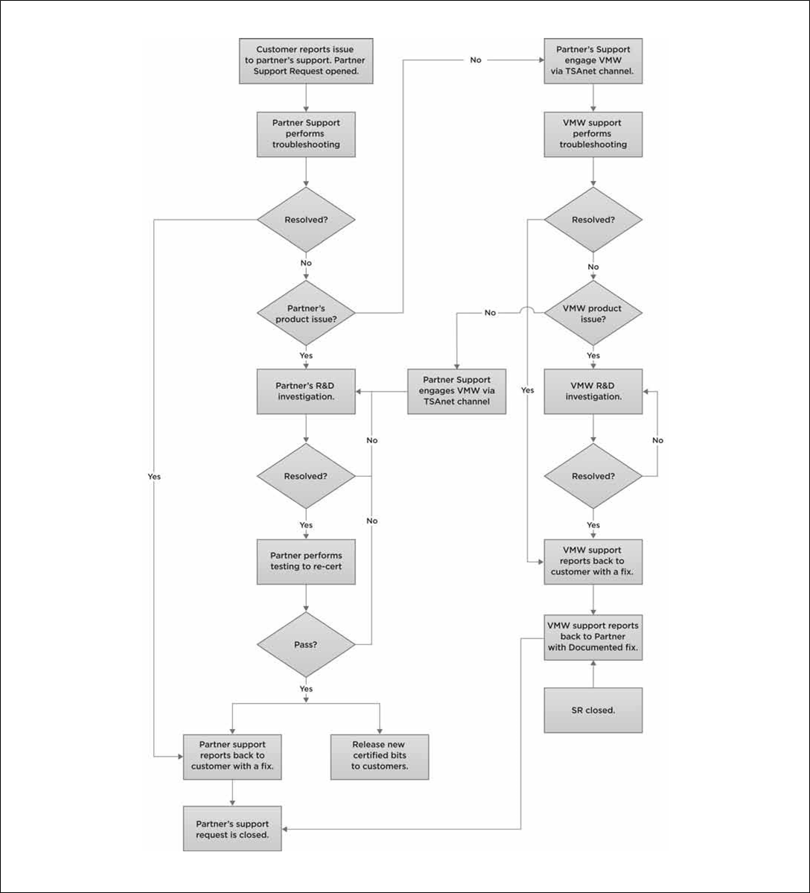

Figure 3: VMware Customer Contacts Support Flow.

Appendix D: Partner Customer Contacts Support Flow
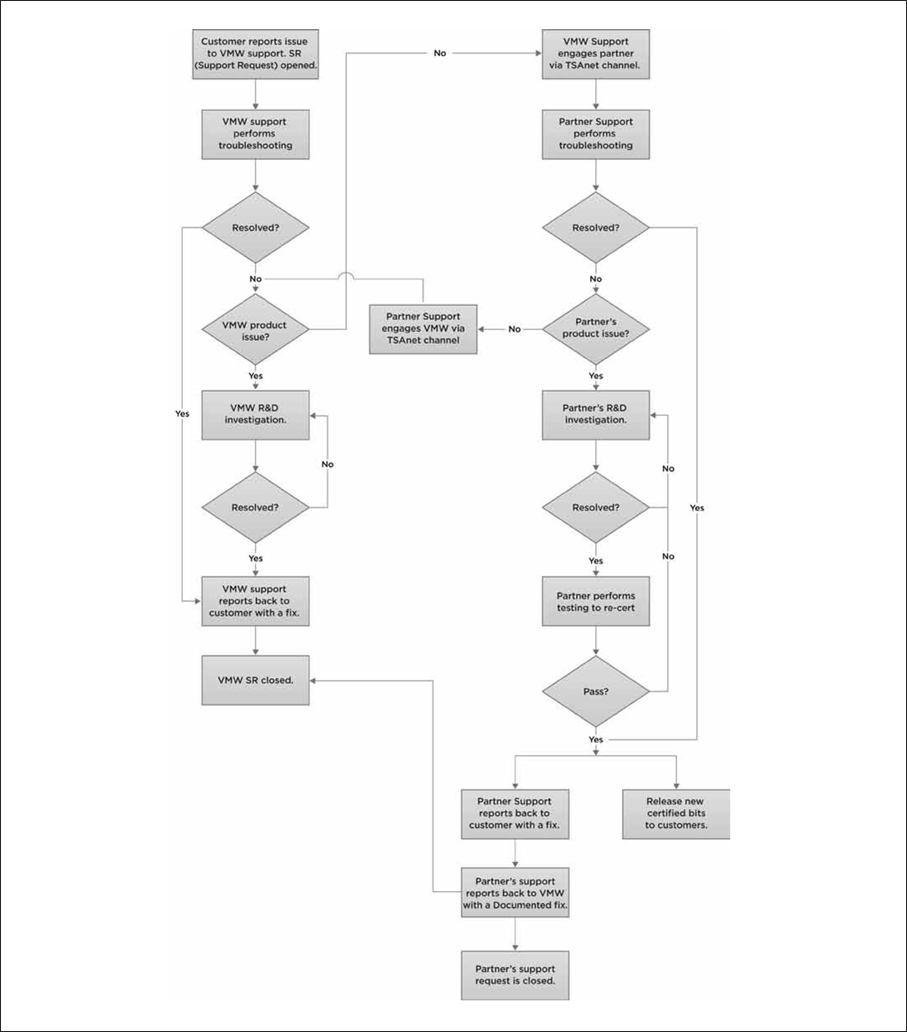

Figure 4: Partner Customer Contacts Support Flow.

Appendix E: Transfer of Information (TOI)
Partner shall provide TOI training for VMware (e.g., support, sales, sustaining engineering, QA, Alliances). Partner shall provide a short training to VMware personnel on the specifics of troubleshooting the Partner Software to help isolate the issue.
Note: Partner shall be responsible for supporting the Partner Software. This TOI is intended to ensure that VMware support engineers can easily isolate issues and smoothly engage Partner’s support team for further troubleshooting.
Partner shall provide access to additional TOI materials at no charge upon the availability of any updates, upgrades or new versions of Partner Software. Partner’s TOI material should cover troubleshooting, internally developed tools, and access to Partner’s knowledge database, as necessary to get knowledge of their Partner Software when isolating reported issues.
A significant amount of content can be handled through documentation, which can keep an interactive information transfer to a very short duration. During the interactive session, Partner should, at a minimum, show VMware personnel the error logs from both good states and failed states, and explain the errors codes (or refer to documentation), so that VMware personnel have a basic understanding of what can be expected when fielding customer calls.
The session should be done via WebEx or some other method that enables recording of the training session.
Information to be documented for mutual customers of selected parts being presented at the TOI includes:
- Prerequisites for Partner Software.
  - SW pre-requisites (perl, java, array management software, etc.)
  - HW prerequisites (array HW and firmware versions, visibility, credentials, etc.)
  - Licensing requirements (yes/no) If yes, please provide details.
- Partner Software installation (if applicable): step-by-step installation guide.
- Partner Software initial configuration (config files, UI parameters, special options, etc.), documented list of pre and post installation configuration and optional parameters.
- Release notes and version information (to include information on known and fixed issues).
- Product behavior, information on failback process.
- Array capabilities and basic administration.
- Troubleshooting:
  - List of all error messages, what they mean, appropriate remedies.
  - Log files with known results (to include what the Partner Software injects into the Partner Software logs). This should be further broken down to clearly identify:
  - Expected good output and what it means (i.e. what is expected when everything is running correctly).
  - Expected bad output and what it means, such as:
    - This XML block means the arrays can’t see each other.
    - This XML block means that the LUN is not replicated.
    - This XML block means that something else is broken.
- Log files with error messages with a “verbose mode” option. (Verbose option should be available, but turned off by default; it could be invoked when it is not possible to make a good determination from the default logs.)
- URL location where customers download the Partner Software.
- URL location where customers can see their support policy for Partner Software.

Appendix F: Sample Partner Contact Information Form
Partner Alliance/Business Contact
Employee Name:
Title:
Address:
Phone:
Email:
Role and Responsibility of Contact: Help with strategic Partner alignment and getting legal agreements signed.

Partner Engineering Manager Contact
Employee Name:
Title:
Address:
Phone:
Email:

Partner Technical Support Manager Contact
Employee Name:
Title:
Address:
Phone:
Email:
Role and Responsibility of Contact: Manage the support relationship with VMware. He/she will be responsible and will act as a single point of contact for all support related activities including escalations and the management of the TSANet infrastructure. He/she should ensure the overall support readiness and training of their support organization to support their Partner Software.

Appendix G: Glossary of Terms and Acronyms
This Appendix defines acronyms and terms used in this guide.
API Application Programming Interface
CLI Command Line Interface
EASE Ecosystems and Solutions Engineering
EULA End User License Agreement
GA General Availability
GSS Global Support Services
HCL Hardware Compatibility List
KB Knowledge Base
PRD Product Requirements Document
QA Quality Assurance
RC Release Candidate
SAN Storage Array Network
SDK Software Development Kit
SR Support Request
TAP Technology Alliance Partner
TOI Transfer of Information
TSANet Technical Support Alliance Network
vC Ops vCenter Operations Manager
VCG VMware Compatibility Guide
VCP VMware Certified Professional

Appendix H: VMware Pre-Release Material(s) and Development Kit(s)
Under this Program, VMware may provide to Partner the VMware Pre-Release Material(s) or VMware Development Kit(s) listed below. Partner’s use of the VMware Pre-Release Material(s) or VMware Development Kit(s) is subject to the terms and conditions of the Program Agreement.
VMware Pre-Release Material(s):
- VMware ESXi 6.x, 7.x
- VMware WorkBench 3.x
- VMware vCenter Server 6.x, 7.x

VMware Development Kit(s):
None Applicable.

